**Question 1)**

AREA assignment3, code, READONLY

ENTRY

LDR r0, = UPC ; put the string from memory location UPC into r0 to read the string

MOV r1, #0 ; put number 0 into register one to begin the pointer for even numbers

MOV r2, #1 ; put number 1 into register two to begin the pointer for odd numbers

Sum LDRB r3, [r0, r1] ; loads the register 3 with a byte from the memory location at r0 pointing from register 1

LDRB r4, [r0, r2] ; loads the register 4 with a byte from the memory location at r0 pointing from register 2

SUB r3, r3, #48 ; takes the ASCII value from the byte in register 3 and converts it into a number int by subtracting 48

SUB r4, r4, #48 ; takes the ASCII value from the byte in register 4 and converts it into a number int by subtracting 48

ADD r5, r5, r3 ; complete the first sum by adding up all of the even numbers in register 3

ADD r6, r6, r4 ; complete the second sum by adding up all of the odd numbers in register 4

ADD r1, r1, #2 ; increment the even pointer by 2 to get the next element in the UPC string

ADD r2, r2, #2 ; increment the odd pointer by 2 to get the next element in the UPC String

CMP r1, #12 ; check to see if the counter in register one has finished with the 10th element and is about to begin the 12th element (done)

BNE Sum ; if it is NOT equal to 0, this means it is not yet pointing to the 12th digit which means it still has to compute digit number 10, so loop again at directive Sum

ADD r5, r5, LSL #1 ; multiplying the first sum by 3 using a logical shift by one unit, and adding it to the second sum (odd numbers)

ADD r1, r5, r6 ; add the first sum and the second sum together and put it in r1

Loop CMP r1, #10 ; compare register 1 with 10 to see if it can be subtracted from r1 sum total

BMI Invalid ; if subtracting 10 from register one results in a negative, then we have our remainder which is less than 10 and go to exit

SUBS r1, r1, #10 ; the number in register 1 is >= 10, so subtract from it and update the flags

BEQ Valid ;if the result of subtracting 10 from the register equals a 0, it means we have a remainder of 10 successful

BNE Loop ; If the result from the previous subraction operation is a non-zero result, go back to Loop and check again if we can keep subtracting

Valid MOV r0, #1 ; The computation is valid therefore move 1 into register 0 to state so.

B Finish ; Jump to finish to exit the program

Invalid MOV r0, #2 ; the computation is invalid therefore move 2 into register 0 to state so.

Finish ; The jump directive which will end the program for both valid and invalid.

UPC DCB "013800150738" ; UPC string

END

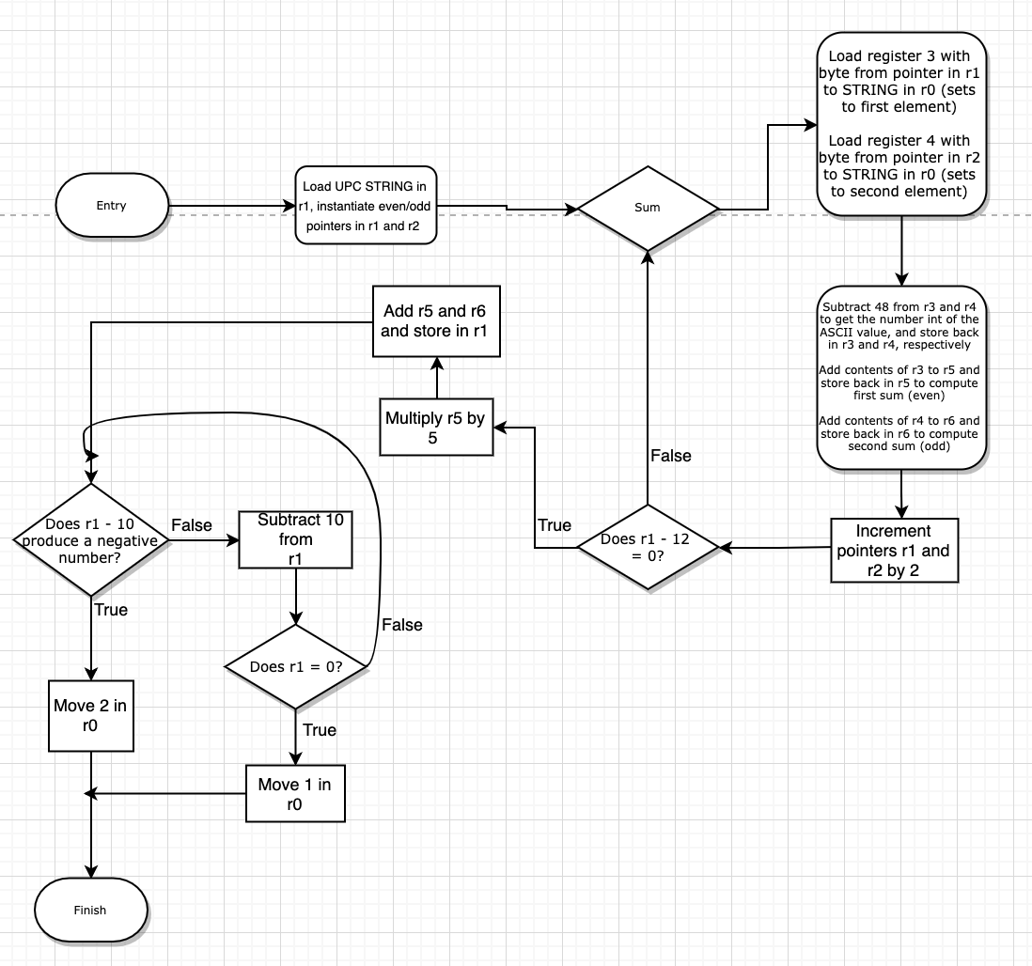

Question 2)

AREA prog2, code, READONLY

ENTRY

ADR r1, STRING ;generate an address to STRING in register 1 to allow the pointers to use it when receiving the ASCII characters (bytes)

ADR r2, EoS ;generate an address to EoS (end of the string) in register 2 for a label

NXTLEFT LDRB r3, [r1] ;load a single byte storing the character from STRING in r1 to r3 to allow for the pointer

ADD r1, #1 ;load the pointer with 1 to check the next byte in the string. This will keep increasing in each iteration.

CMP r3, #0x41 ;compare the ASCII letter in register 1 to "A" to see if it is below or above it

BLT NXTLEFT ;the letter in r3 is smaller than "A" then branch to NXTLEFT to get a new character (it is not an acceptable letter)

CMP r3, #0x5A ;compare the ASCII letter in register 1 to "Z" to see if it is "A" < letter < "Z" which makes it acceptable

BLT NXTRIGHT ;the letter is between A-Z which is acceptable so get the second letter from NXTRIGHT to compare with the other end as well

CMP r3, #0x61 ;compare the ASCII letter in register 1 to "a" to see if it is "Z" < letter < "a"

BLT NXTLEFT ;the ASCII letter is between Z-a which is an unnacceptable letter so get a new one

CMP r3, #0x7A ;compare the ASCII letter in register 1 to "z" to see if it is "a" < letter < "z"

BLT NXTRIGHT

B NXTLEFT ;the leter is not in our defined parameters which means it is > "z", so it is unacceptable - fetch a new one

NXTRIGHT LDRB r4, [r2, #-1]! ;load register 7 with the pointer starting from the end of the string and moving left

CMP r4, #0x41 ;compare the ASCII letter in register 4 to "A" (r4 - "A")

BLT NXTRIGHT ;if the letter is smaller than "A" now get a new character

CMP r4, #0x5A ;compare the ASCII letter in register 4 to "Z" to see if it is "A" < letter < "Z"

BLT CHECK ;the letter is valid so branch to check to see if r3 = r4

CMP r4, #0x61 ;compare the ASCII letter in register 4 to "a" to see if it is "Z" < letter < "a"

BLT NXTRIGHT ;the letter is in unnacceptable format so fetch a new one through NXTRIGHT

CMP r4, #0x7A ;compare the ASCII letter in register 4 to "z" to see if it is "a" < letter <"z"

BLT CHECK ;If the letter is less than z, it means it is any lower case letter which is acceptable, now branch to CHECK to see if r3 = r4

B NXTRIGHT ;the letter is not in our defined parameters which means it is > "z", fetch a new one

CHECK CMP r3, #0x61 ;compare letter "a" with ASCII letter in register 3 which will tell us in the next line if it is greater than a (a lower letter)

SUBGT r3, r3, #0x20 ;the letter is lower case, subtract 20 to make it capital so that we can make evrything case insensitive

CMP r4, #0x61 ;compare letter "a" with ASCII letter in register 4 which will tell us in the next line if it is greater than a (a lower letter)

SUBGT r4, r4, #0x20 ;the letter is lower case so subtract it by 20 to get it's capital equivalent to make everything case insensitive

CMP r3, r4 ;compare the two letters in registers 3 and 4 to see if they equal each other or not which will tell us if they are a palindrome

BEQ CHECKLOOP ;If they equal each other (r3 - r4 = 0) then there is a palindrome go to CHECKLOOP to see if we have checked all the letters

B NOTPD ;They do not equal each other, branch to NOTPD to signify it is not a palindrome and end the program

CHECKLOOP CMP r1, r2 ;compare registers 1 and 2 (r1-r2) which store pointers to the left/right side of the string to see if they have reached the middle yet

BGE ISPD ;the pointers have reached the same value, now go to DONE to move 0 in r1 and finish

B NXTLEFT ;the pointers still have not reached the middle as they are not equal to each other - branch to NXTLEFT to get the next iteration of letters

ISPD MOV r0, #1 ;since the string is a palindrome and we have already checked all of the bytes, move 1 into register 0

B FINISH ;the program is complete, branch to FINISH to end

NOTPD MOV r0, #2 ;the string is NOT a palindrome, move 2 in register 0 and end the program via FINISH

FINISH

STRING DCB "He lived as a devil, eh?" ;string

EoS DCB 0x00 ;end of string

END

